How various predictors (age, gender, bmi..etc) effect claim amounts
Appendix
1. Initial data exploration
1.1
Check for rows with empty variable numbers.
Since out of 1340 rows, only 8 rows have missing numbers, it was decided that those rows with missing values to be dropped.
1.2
We have both numeric and categorical predictors.
First we visualise the distribution of the numerical variables (using histograms):
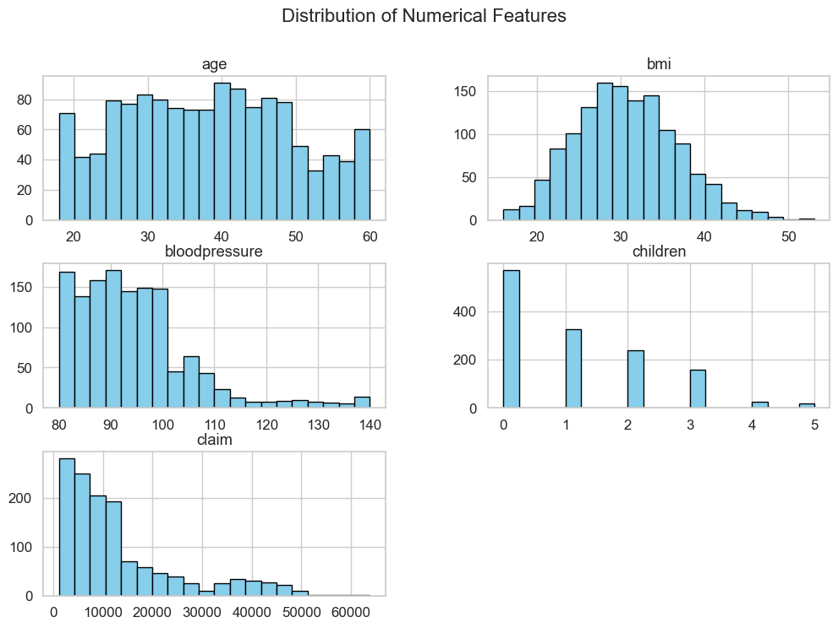
Then we visualise the distribution of categorical variables (using bar plots):
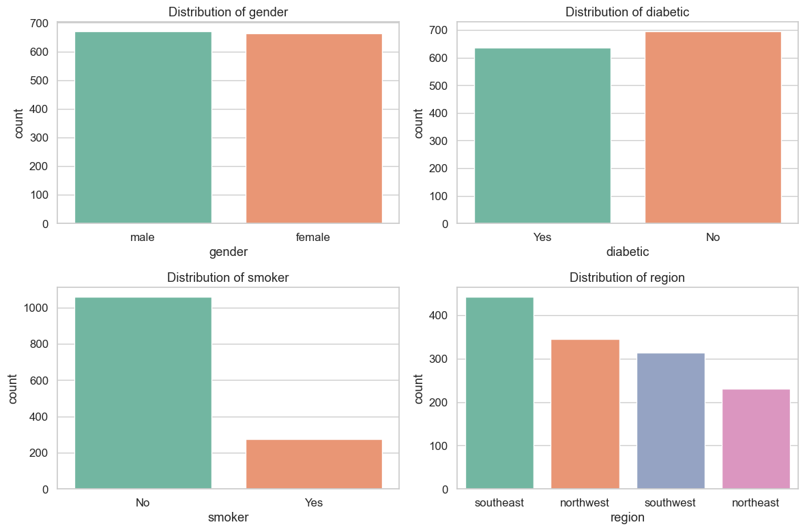

1.3 (Two way summaries of the relationship between potential predictors and target variables – for categorical variables as can’t find correlations for them)
Relations between gender & smoking status AND “average” insurance claims
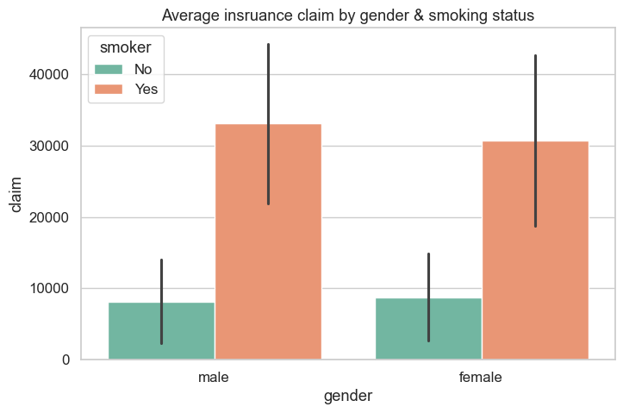
- From this, whether a person is male or female does not affect the claim amount
- However, being a smoker does increase the average claim amount

Relations between region & diabetic status AND average insurance claims
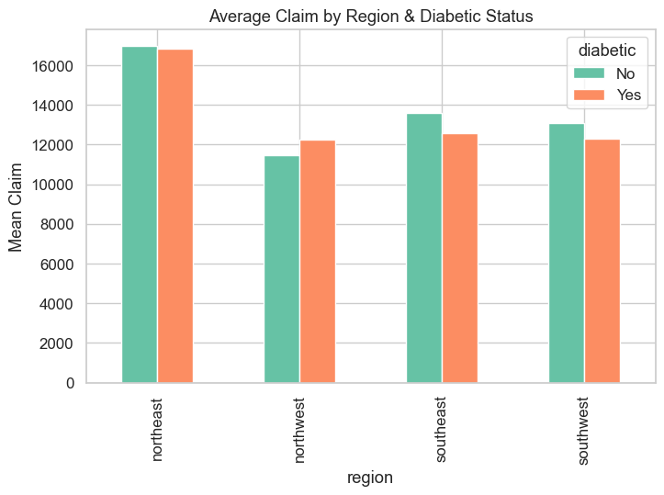
- Generally northeast has higher claims
- Whether diabetic or not doesn’t really lead to higher mean claims

Relations between region & smoker AND average insurance claims
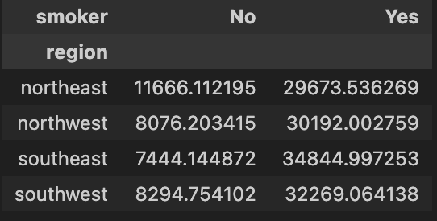
- Smokers have higher mean claims (the regions doesn’t matter)
- For non-smoking individuals, northeast has noticeable higher mean claims

Relations between diabetic & children AND mean insurance claims
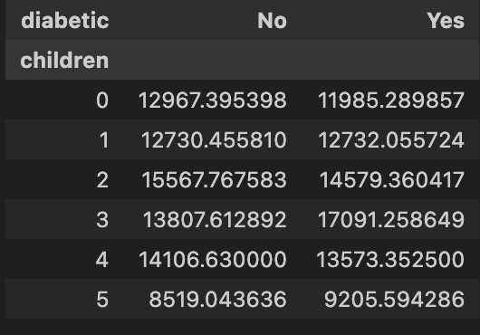
- No noticeable trends based in diabetic & children
1.4 correlation between predictors (ofc numerical variables only)
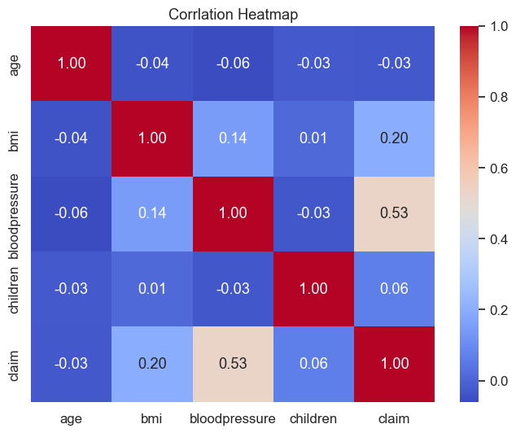
- No noticeable correlation besides blood pressure and claim

1.5 relationship analysis (1/2/3-way summaries)
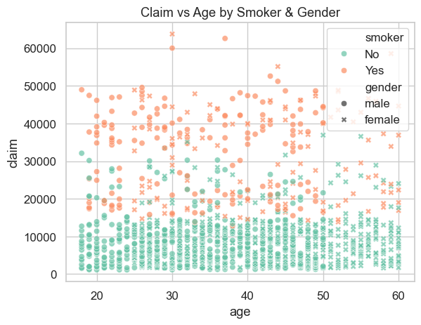
- Clearly smokers have higher claims
- gender and age seem to have no effect

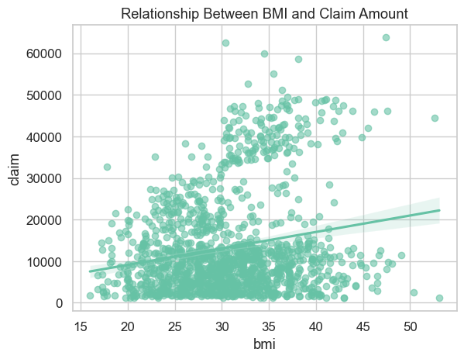
- bmi: 30~45 seems to show more frequent higher claim amounts
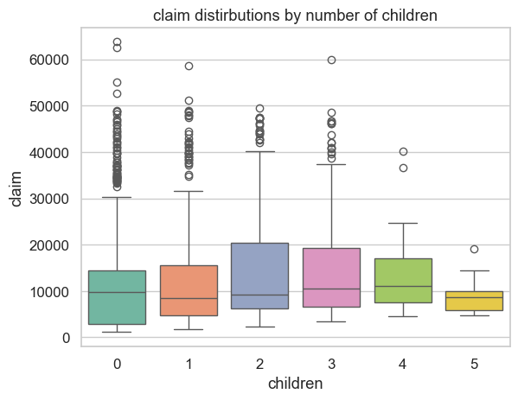
- individuals with 2 and 3 number of children tend to have Higher claims
1.6 creating new variables (going from continuous to band to see group effects)
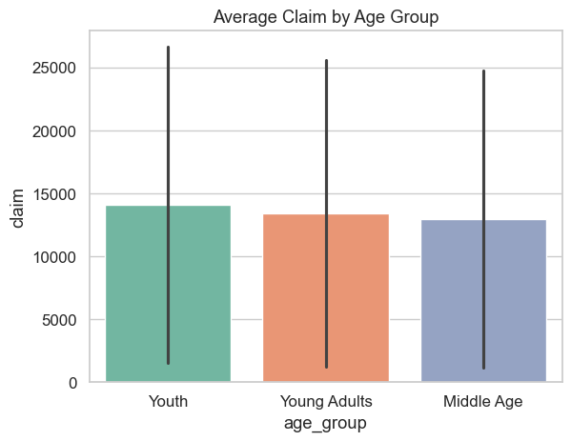
- for age, group them into diff categories
- based on age group, no significant differences (just a slight decrease in claims on older group)
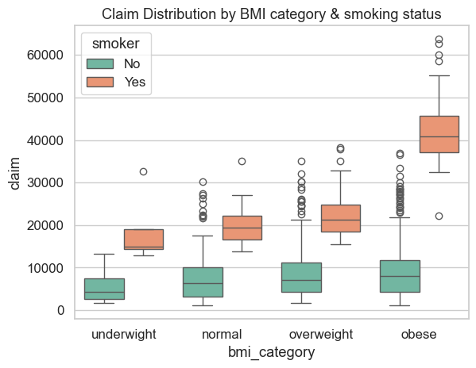
- for bmi, grouped them into diff categories
- also hue the smoker
- clearly, smokers have higher claims
- also, the higher bmi groups tend to have higher claims (especially for smoking and obese)
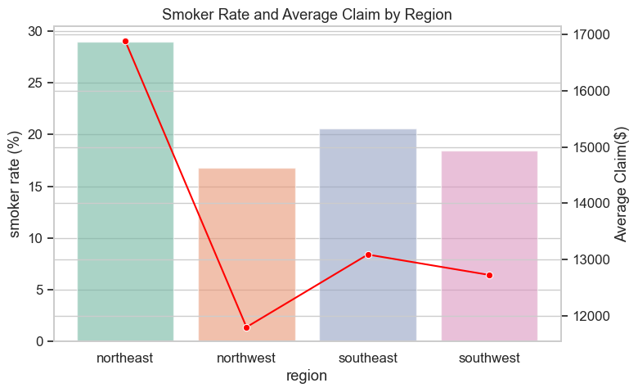
- for each region, calculated two variables: smoker rate (barplot) and average claim (line)
- from this can see that the region with higher smoking rates had higher claims

2. Linear Models
2.05
70% of the data was used as a training data to train the models represented below.
Using the other 30% as the test data, the MAE and RMSE for each trained models were calculated.
2.1 Multiple linear regression
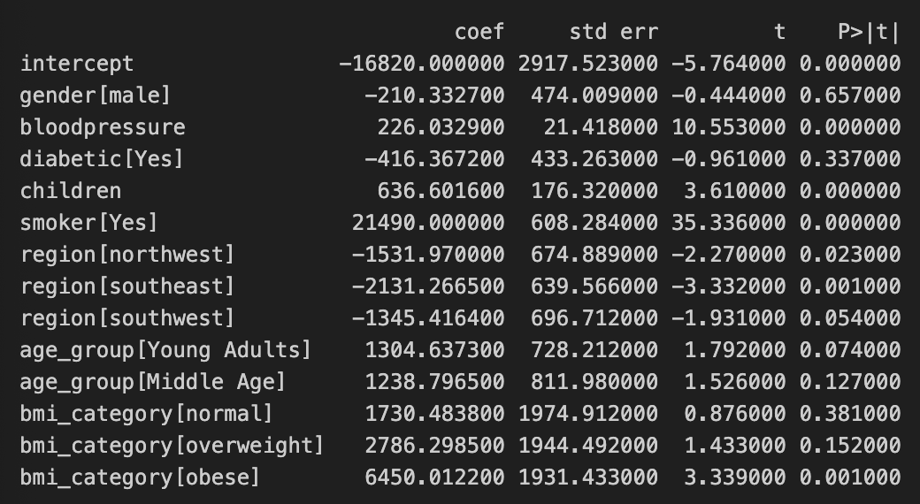
Response variable as claim and gender, bloodpressure, diabetic, children, smoker, region, age_group, bmi_category as predictor variables.
- It seems like gender, diabetic, age-group, bmi_category[normal], bmi_category[overweight ]have no impact on claim size

2.1.1 fitted vs residuals
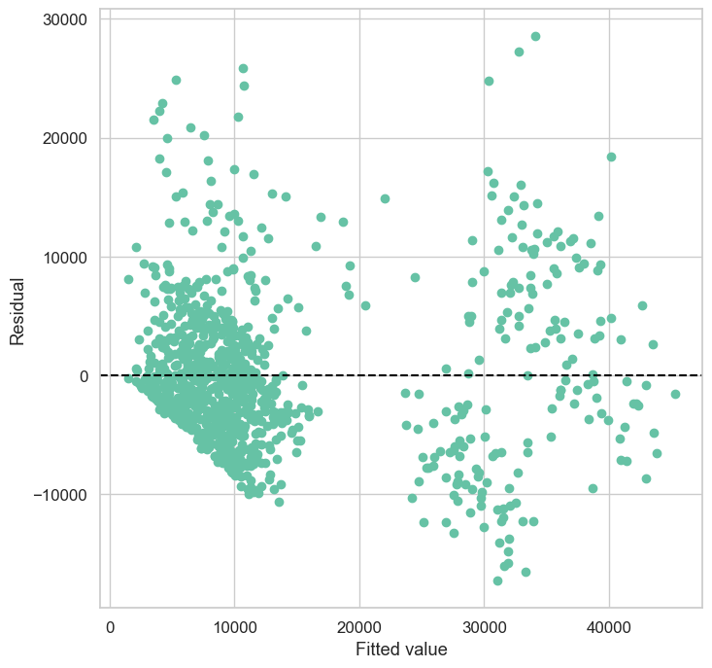
- With fitted value, the spread of residual changes -> non-constant variance of the error term
- Residuals show systematic patterns, within the 1000~15000 fitted values, where the spread of residuals increase by more negative residuals present as fitted values increase non-linearity
- Hence, “linear” regression is not a valid fit

2.2 GAMs
Since linear regression wasn’t a valid fit, let us consider GAMs with splines to capture non-linearities

2.2.1 Gamma GAM
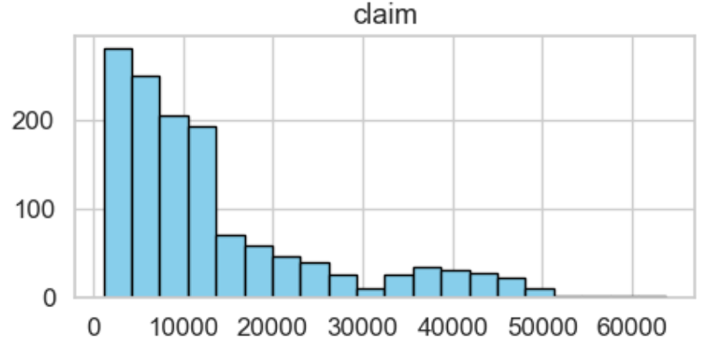
Recall that claims are always positive.
Also, the right skewed long tail means distribution is not symmetric / normal.
Hence, Gamma GAM with log link function would be appropriate.
The GAM was constructed as follows:
- A smoother spline effect on bloodpresssure variable, using 10 spline basis functions
- A smoother spline effect on children variable , using 10 spline basis functions
- A categorical effect for all other categorical variables with no smoothing penalty done
The result:
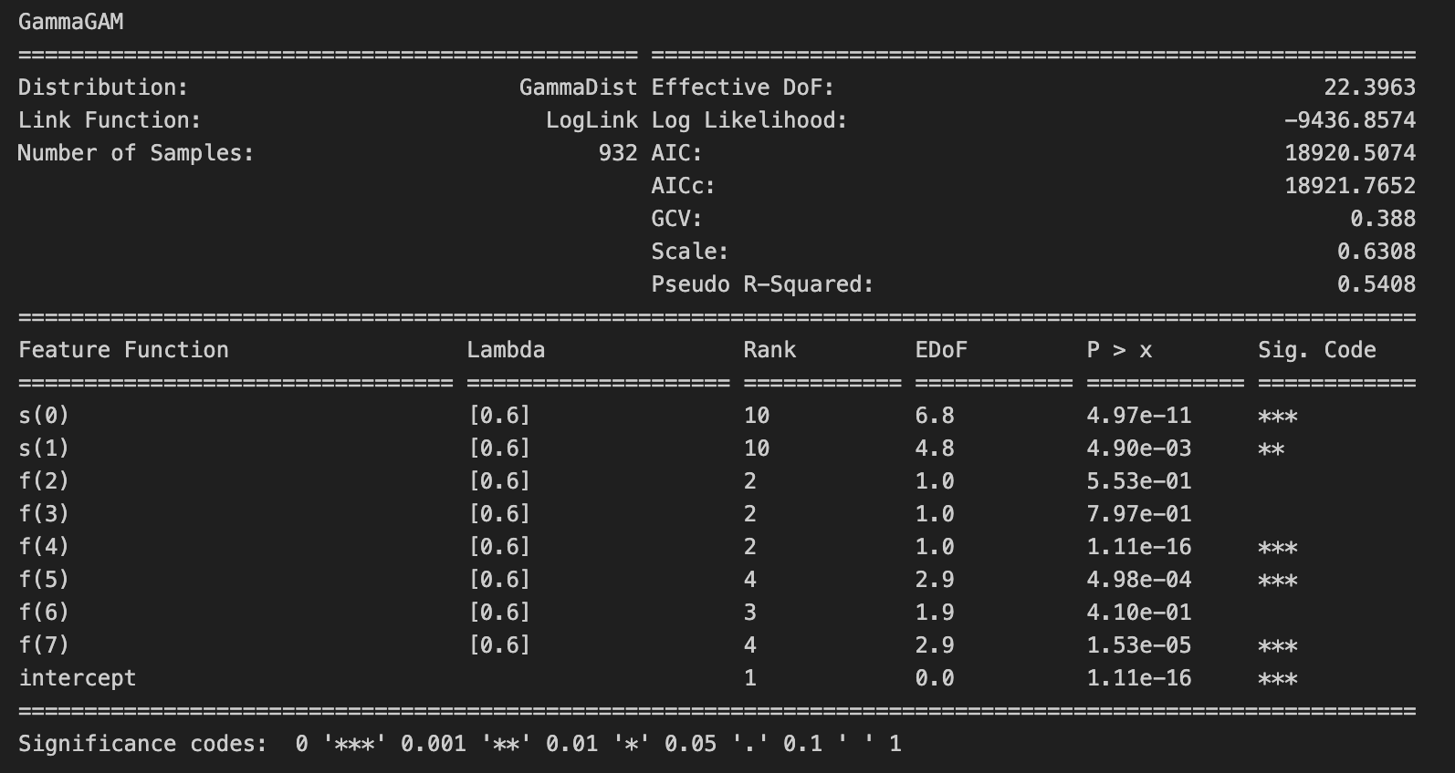

3. Tree-Based Models
Tree-based models were also considered to model this data.
3.1 Bagging
First, the default bagging method (considering all predictor variables, when doing the split in the tree) was used to do regression by using the training data. The test MSE turned out to be 313,102,25.
3.2 Random Forests
Next, random forests modelling method was used (which considers only 4 predictor variables out of 13 variables when doing split in the tree). The MSE was slightly lower with 310,443,41, indicating that random forests method was slightly better.
3.2.1 The importance of each variable
Extracting the feature_importances_values from the fitted random forests model, the importance of each variable was viewed:
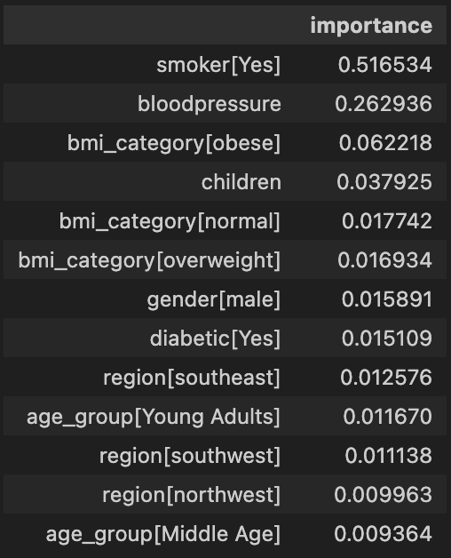
- Aligning with previous findings, smoker variable was still regarded as one of the most important variables.
3.3 Boosting
Finally, boosting (specifically XGBoost) was considered with 3000 trees of max depth 3 and learning rate λ of 0.01.
The test MSE obtained after training the model was 30339613, lower than bagging and random forests.
4.1 Results from modelling
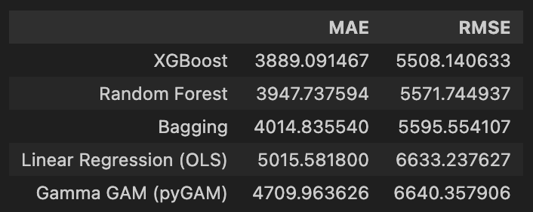
From the results in the table, XGBoost achieved the lowest MAE and also the lowest RMSE, meaning it is best on both typical dollar error and big-claim error control respectively. Random forests have slightly worse MAE/RMSE than GBM, often more robust with less tuning. The OLS / Gamma GAM underfit the real nonlinear structure, indicated viahigher MAE/RMSE.
Ultimately, using MAE as the primary severity metric, XGBoost provided the best predictive performance and is selected as the preferred claim severity model.
5.1 Deployment
The model was deployed as a Streamlit web app. User inputs are transformed using the same saved feature engineering pipeline and category encodings as the training data, then passed to the stored trained model to produce real time insurance payment predictions.

